**Gen4 Memory Map & protocol**

2016.12.12

JSPARK

**Revision history**

|  |  |  |
| --- | --- | --- |
| **Date** | **Version** | **Description** |
| **2016.10.14** | **1.0** |  |
| **2016.11.24** | **1.1** | **Modify protocol & add description** |
| **2016.12.12** | **2.0** | **Modify protocol** |

**Contents**

1. BLE(Bluetooth Low Energy) Interface 2

1.1 The GEN4 Persona Interface diagram shows the basic logic connection. 2

1.2 BLE Scan 2

2. System flow Chat 2

3. Command Message Summary 3

4. Data definitions 4

4.1 Initial Protocol 4

4.2 Measurement Protocol 6

4.3 Setting Protocol 7

5. Cal of PCAP02(sensor1~sensor6) of FTS 8

5.1 Summary 8

5.2 PCAP02 low data 8

5.3 Scale calculation 9

5.4 lB Scale calculation 9

5.5 Load Accuracy test 11

5.6 PC -> Board data write 11

6. Cal of PCAP02(sensor1~sensor6) of GUI 12

7. Cal of Battery Calibration(Battery Calibration program) 12

8. Cal of Battery Calibration(FTS) 12

8.1 contents 12

8.2 Example 12

9. Cal of IMU(FTS) 13

10.Cal of IMU(GUI) 13

1. BLE(Bluetooth Low Energy) Interface
   1. The GEN4 Persona Interface diagram shows the basic logic connection.

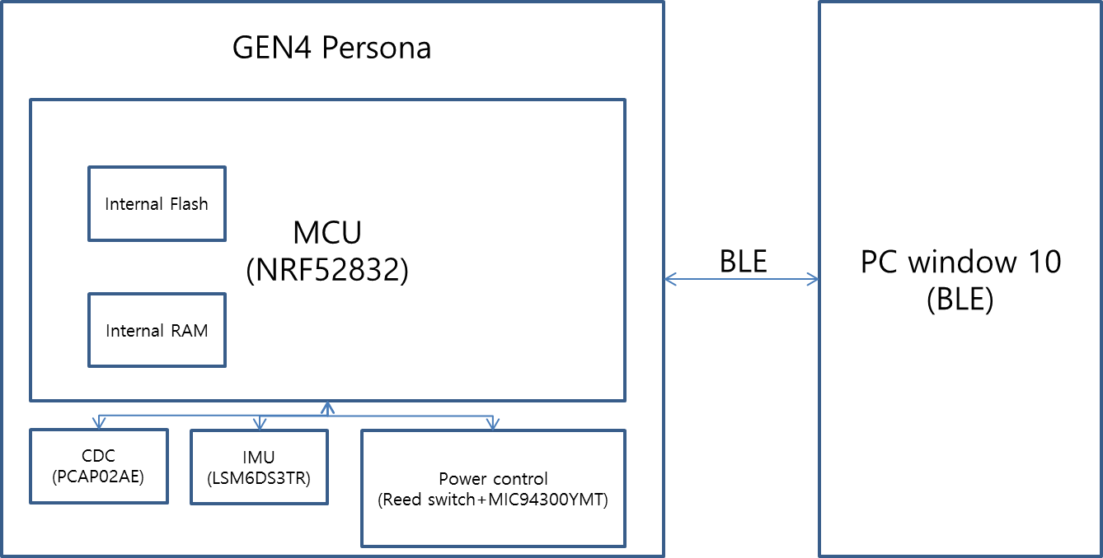

* 1. BLE Scan
     1. CompleteLocalName : GEN4_PERSONA
     2. Address : MAC address of the product
  2. nRF52832 program memory 0x1c000 ~0x24580 currently in use

1. System flow Chat

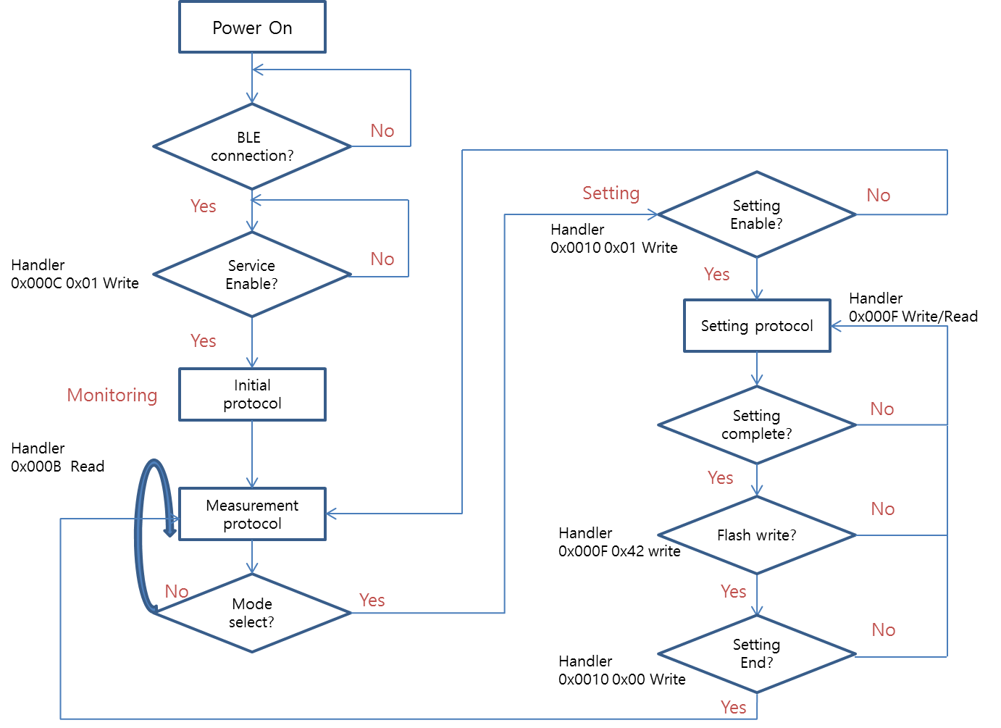

Setting end -> disable

1. Command Message Summary



1. Data definitions
   1. Initial Protocol



* + 1. Configuration
       1. UUID : 00000001-1212-EFDE-1523-785FEF13D123
       2. Handler : 0x000B
    2. Packet information
       1. Total 18 Byte
* Packet ID (1 Byte) / ROM data (16 Byte) / Data counter (1 Byte)
  + - * 1. Packet ID 00(h), Data counter 00~02 : Green section
        2. Packet ID 01(h), Data counter 03~05 : Purple section
        3. Packet ID 02(h), Data counter 06~08 : Blue section
      1. Detail Initial Protocol
         1. Green section(Device information)



* + - * 1. Purple section(IMU, Batt Cal information)



* + - * 1. Blue section(PCAP zero information)



* 1. Measurement Protocol



* + 1. Configuration(same initial protocol)
       1. UUID : 00000001-1212-EFDE-1523-785FEF13D123
       2. Handler : 0x000B
    2. Packet information
       1. Total 33 Byte
* Packet ID (1 Byte) / Serial number (4 Byte) / Measurement data (26 Byte) / Data counter (2 Byte)
  + - 1. Packet ID 12(h), Data counter start 09
      2. Detail Measurement Protocol



* 1. Setting Protocol
     1. Configuration
        1. UUID : 00000002-1212-EFDE-1523-785FEF13D123
        2. Handler : 0x000F
* Use the same format as the initial Protocol
* Only the Packet ID is different
* For example, Device information is as follows.
  + 1. Device information



* Example : GUI Write data
* Must write on line at a time



* Inner Flash Memory start 0x7e000

1. Cal of PCAP02(sensor1~sensor6) of FTS
   1. Summary

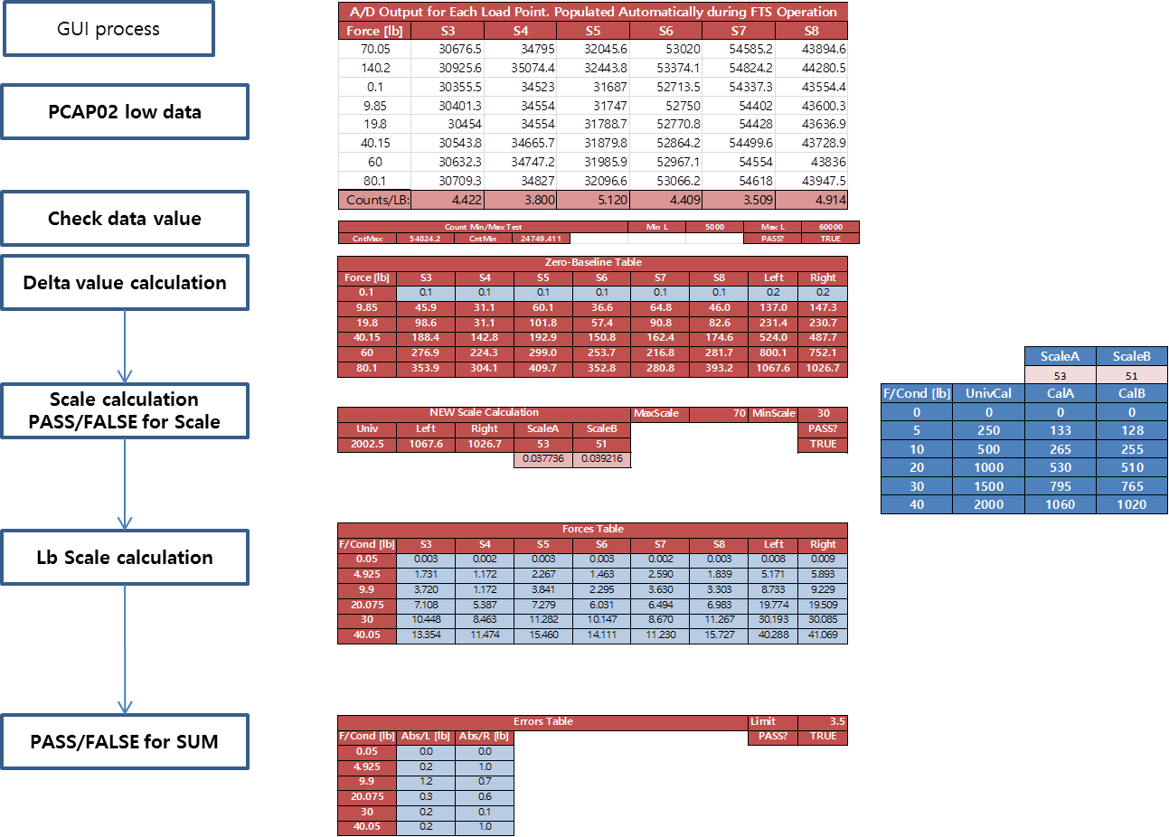

* 1. PCAP02 low data

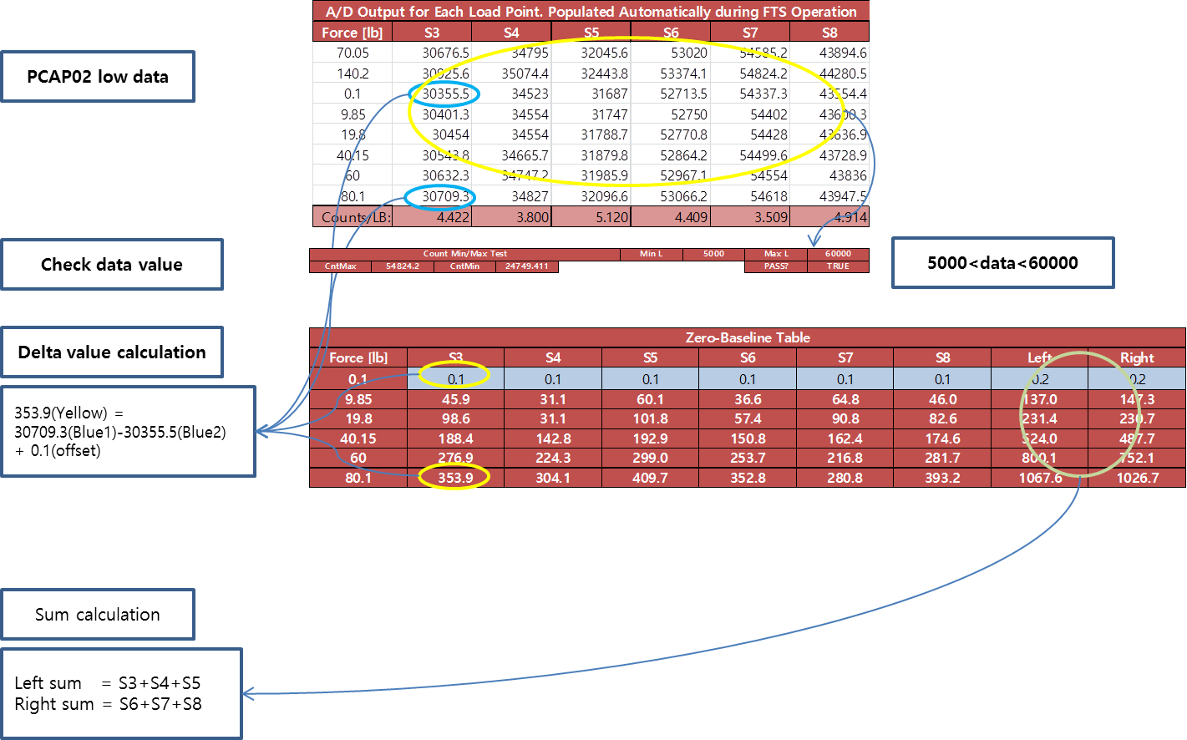

* 1. Scale calculation

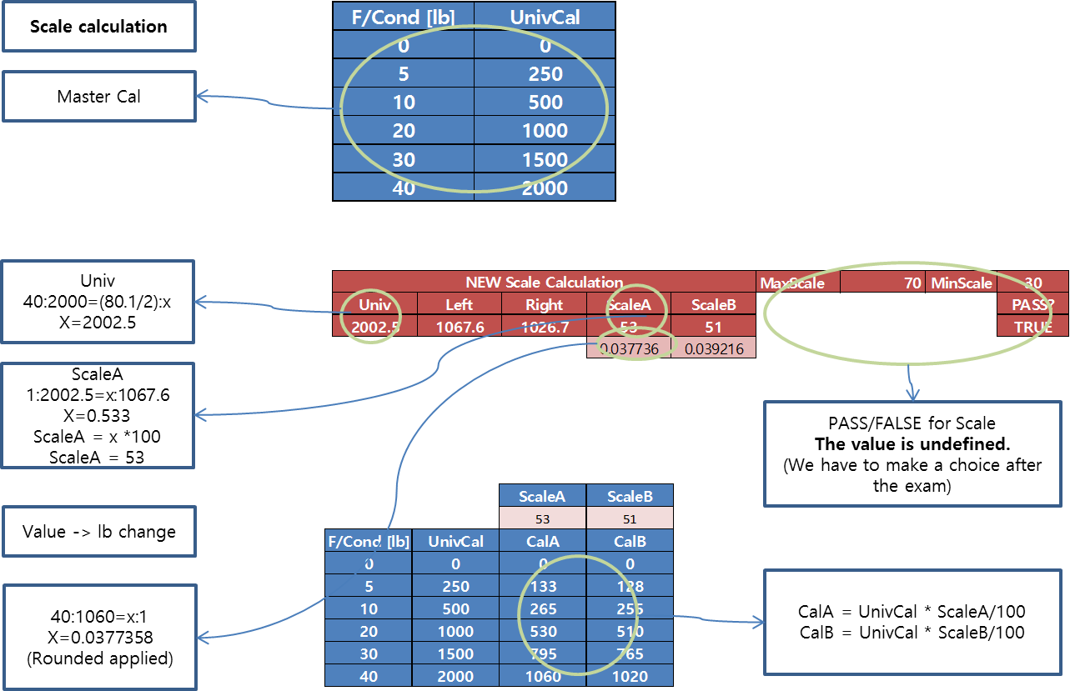

* 1. lB Scale calculation

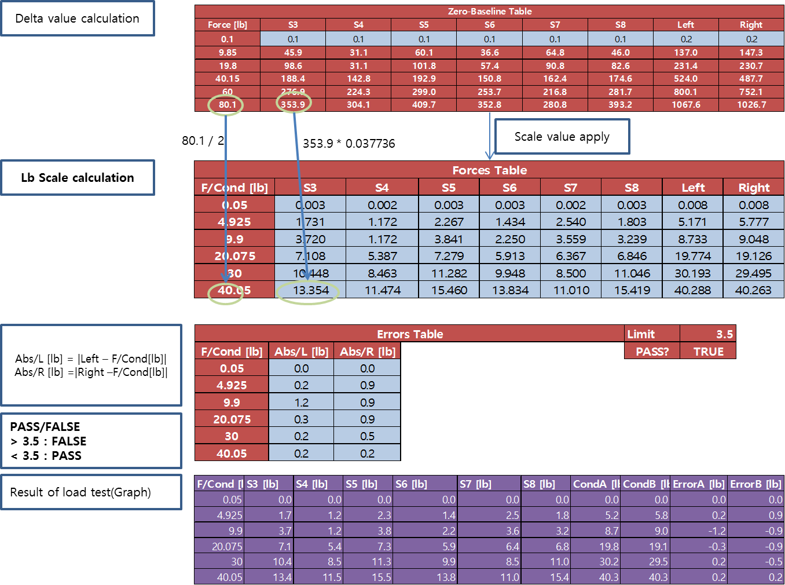

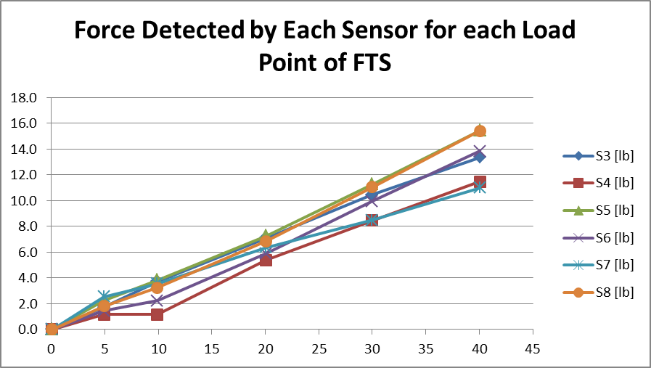

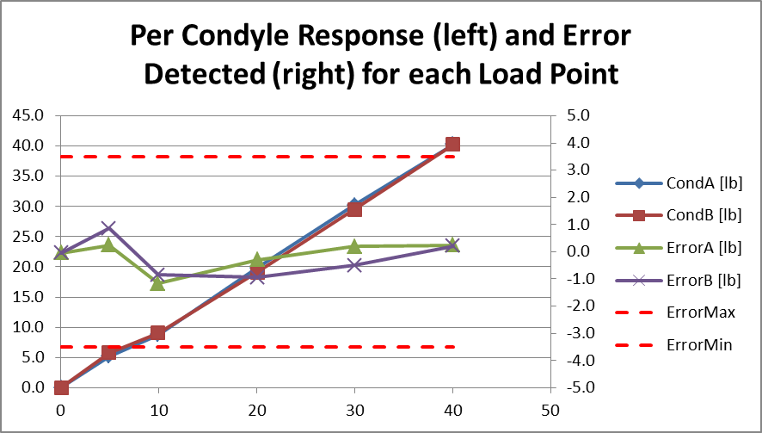

* 1. Load Accuracy test

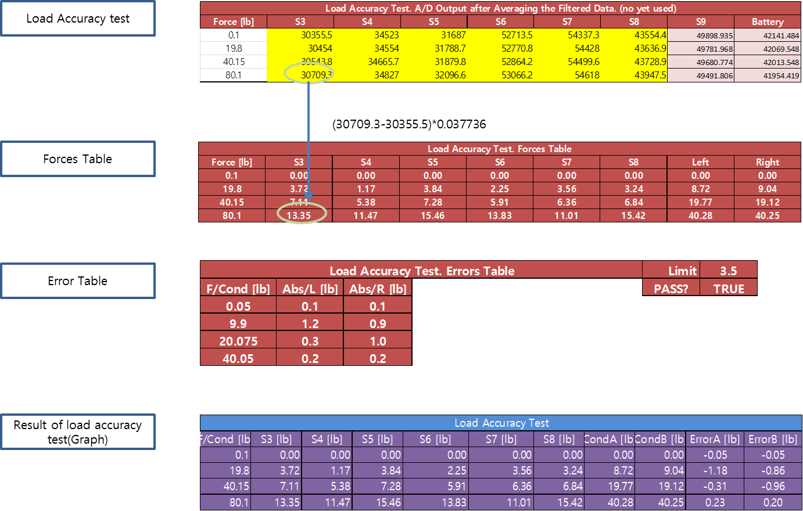

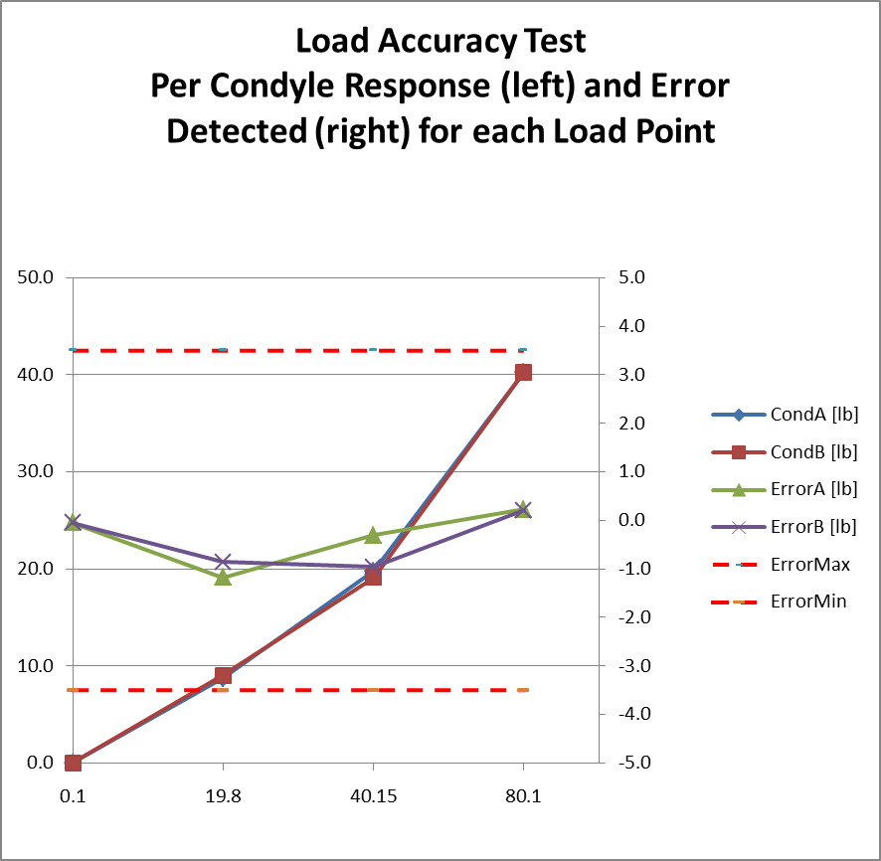

* 1. PC -> Board data write
     1. Setting device information and Sensor zero
* Device ID, Year, Month, Day, Device Type, Manufacturer/Lot ID, Cal Factor for CondlyeA, Cal Factor for CondyleB
* Offset of sensor1~6 ‘0’ value

1. Cal of PCAP02(sensor1~sensor6) of GUI
   1. Check sensor ‘0’ value (refer to blue section of the Initial Protocol )
   2. Check Cal Factor for CondyleA (scale A), Cal Factor for CondyleB(scale B) value (refer to green section of the Initial Protocol)
      1. Cal Factor for CondyleA(53(D)) , Cal Factor for CondyleB(51(D))
      2. Master value and scale value can be used for conversion. (low data -> lb data)
      3. Create Force table using delta value
      4. Example
         1. If the values of s1(30454), s2(34554), s3(31788) are input, the delta value with the value of ‘0’ is obtained. (‘0’ s1 30355, s2 34523, s3 31687)
         2. Delta value s1(99),s2(31),s2(101), sum (231)
         3. Convert to lb value s1(99*0.037736),s2(31*0.037736),s3(101*0.037736),sum(233*0.037736)

s1(3.735) , s2(1.169), s3(3.811), sum(8.792)



< Applying master value and scale>

* 40 : 1060 = x :1
* X = 0.0377358( about 0.037736)

1. Cal of Battery Calibration(Battery Calibration program)

* TBD

1. Cal of Battery Calibration(FTS)
   1. contents

* Refer to the values obtained using the battery calibration program(Purple section of the initial protocol(IMU, Batt Cal information)).
* Then, measure the battery voltage at the completion of FTS and determine PASS / FALSE.
  1. Example
* Assume that the value of 2.8V is 33688 and the value of 3.1V is 37553.
* Y=ax + b

37553 = 3.1a + b

33688 = 2.8a + b

a = 12883.33

b = 2230.3

* x = (y+2230.3)/12883.33
* If value 36871 is input, the voltage is 3.03V
* FTS check Min, Max
* TBD

1. Cal of IMU(FTS)

* TBD

1. Cal of IMU(GUI)

* TBD